TAU INSTRUCTIONS:

Part A: Healthy Kids

Once a healthy child has scanned:

1. Check the scan reports to see if TAU scans happened on Saturday (or during grabbed time on Tuesday afternoons)
2. Add subject to “fMRI processing tab” and follow steps below for the scans
3. Add subject to “Demographics” tab, “Healthy” tab and “Gender” tab
   1. Demographics:
      1. Age calculator is on the tab labeled “Sheet2”, you just need to enter the date of birth and scan date
      2. IQ, ethnicity and SES come from CTDB (see CTDB data pulling instructions)
      3. DPC before? And TAU before? Refer to if the subject has completed older studies similar to TAU—this will be no for any new participants
      4. Bias stim set comes from the randomization tracker (\\nimhirp-ds1\sdan1$\Data\AttentionRetraining\Tau_NIMH\Forms\TauNIMH_HVbias_randomization”)—this needs to be done before the scan and put into the 3TB scan schedule by at least the Wednesday before the scan
         1. There are 2 tabs—make sure to choose the right one, most likely the fMRI tab because we aren’t doing HV kids in the clinic anymore
      5. Training stim set and Training type are “X” for healthies
      6. Pre location: 3TB or clinic—do not enter this until after the task has been administered because this is where the pivot tables pull from for numbers
      7. Training status is “X” for HVs
      8. Expected end date is 8-10 weeks after the initial scan
         1. It is the TAU IRTA’s responsibility to alert the IRTA that it is time for the subject to be scheduled for the post scan, I usually give them about 1 months’ notice
      9. Post location: same as pre, see step (vi)
      10. Debriefing date: “X” for HVs
      11. Scanned before? Yes, if they have scanned before; no, if TAU is their first scan
      12. Files merged? Once the subject has completed all of TAU (pre and post), you will merge the ePrime files
      13. Clinic and scanner? This is asking if the child completed the task in both locations—should be no for all new subjects since we’re no longer doing TAU in the clinic for HVs
      14. Sibling: make a note if the subject has a sibling or parent or relative also participating in the study
   2. Healthy:

For the scans:

1. **AS YOU PROGRESS THROUGH THESE STEPS, MAKE NOTES IN THE “FMRI PROCESSING” TAB OF THE TAU TRACKER**
2. Add the subject to the “fMRIprocessing” tab in the TAU tracker
   1. Fill in the Subject Type, Scan Date, Visit, Version, Include (“not checked”) and Notes (from the scan report)
3. Calculate the accuracy in ePrime
   1. Navigate to sdan1$\Data\AttentionRetraining\Tau_NIMH\fMRI\Shortcut to TAU-NIMH fMRI data
   2. Open the “E-DataAid 2.0 File”
      1. If the file is not there it is mostly likely because the taskmaster did not transfer the data to the server—you can either wait and see if they do it later or do it yourself
   3. Tools > Analyze > Under “Variables” choose “Probe.ACC” and drag it to the “Data:” box
   4. Hit “Run” 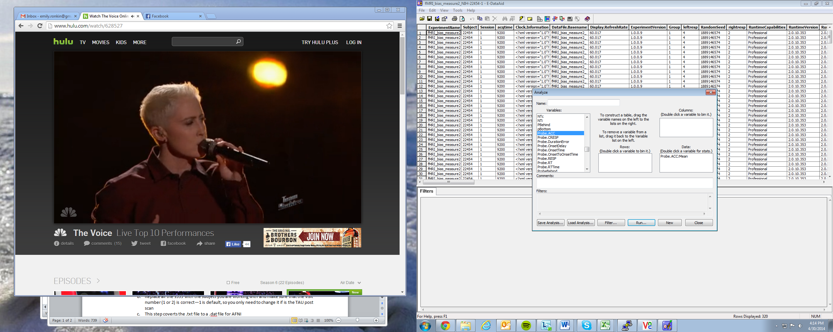
   5. Record the accuracy in the “Healthy” tab
   6. Close out of all the accuracy windows without saving, but don’t close out of ePrime
   7. If the accuracy is less that 75%, exclude for behavior
4. Export the E-DataAid 2.0 File in ePrime
   1. File > Export
   2. Uncheck “Unicode”, hit “OK” 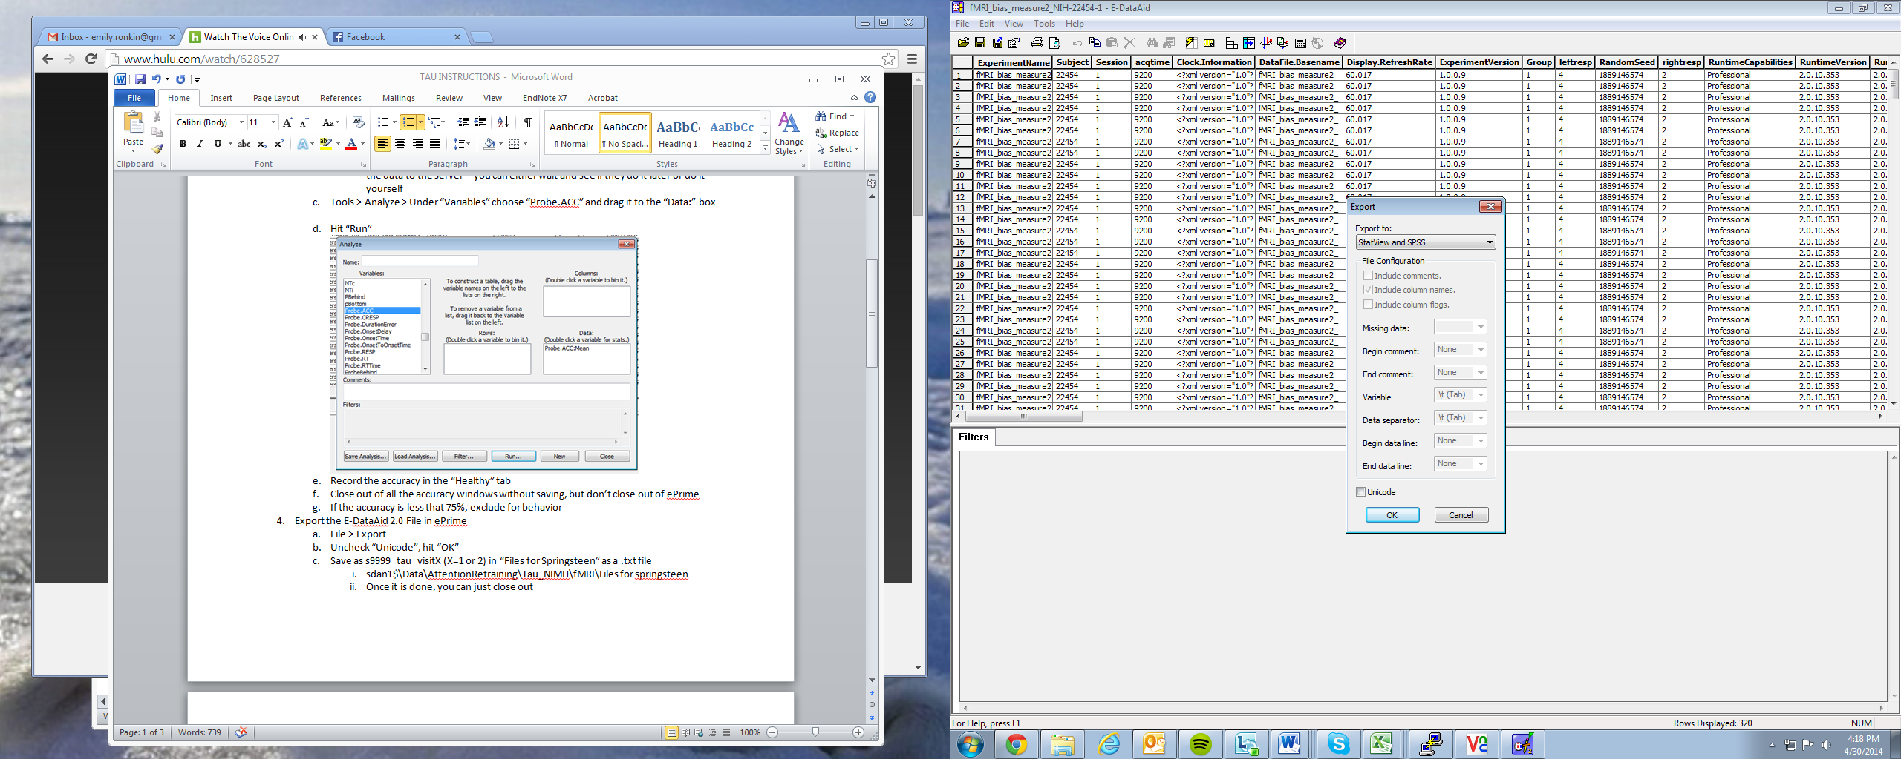
   3. Save as s9999_tau_visitX (X=1 or 2) in “Files for Springsteen” as a .txt file
      1. sdan1$\Data\AttentionRetraining\Tau_NIMH\fMRI\Files for springsteen
      2. Once it is done, you can just close out

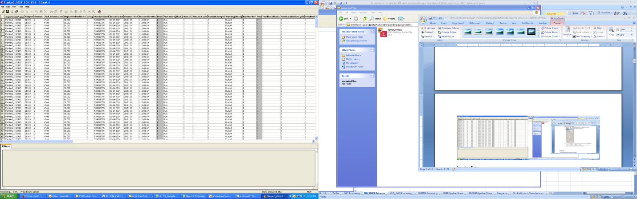

1. Open SPSS syntax file in sdan1$\Data\AttentionRetraining\Tau_NIMH\fMRI\New_laptop_tauextract2
   1. Use the old laptop script for TAU scans BEFORE 4/19/14
   2. Replace all the s999 with the subject you are working with and make sure that the visit number (1 or 2) is correct—1 is default, so you only need to change it if is the TAU post scan
   3. This step coverts the .txt file to a .dat file for AFNI
   4. If this step worked, an SPSS data file will pop up all filled out
   5. Close all SPSS windows without saving, the script automatically saves everything for you
2. Open WinSCP
   1. Copy and paste .dat files from sdan1$\Data\AttentionRetraining\Tau_NIMH\fMRI\Files for springsteen to /raid4/sdanny/workingdata/tau/behav_data/orig
   2. Now the .dat files will show up in VNC
3. Open VNC and navigate to the TAU directory (Lauren can help you make a shortcut)
4. Open the tau_analysis_record
   1. Within the TAU directory type “gedit tau_analysis_record &”
   2. **Record everything you do in VNC in this record**
5. Type “cd scripts” in the tau directory to navigate to scripts
   1. Run open sesame: open_sesame [ID] tau [date of scan]
      1. For visit 1: ./open_sesame 22532 tau 03.22.14 1
      2. For visit 2: ./open_sesame 22380 tau 04.05.14 2
      3. This converts the scan into a form that we can use to do analyses—if you do it more than once it overwrites what you previously did
      4. If this doesn’t work:
         1. Make sure you are in the scripts directory
         2. Make sure the date is entered correctly as well as the visit and SDAN number
         3. Brenda may not have transferred the data yet, it usually takes a couple of days
   2. Run dicom data check: dicom_data_check [ID]
      1. For visit 1: ./dicom_data_check 22454
      2. For visit 2: ./dicom_data_check 22494_2
      3. The functional directories will pop up and ask if they are correct
         1. There should be 2 functional directories, make sure that these 2 are for the 2 TAU runs
         2. If the functional directories are correct, type “y” and hit enter
         3. If the functional directories are incorrect type “n” and hit enter; then type the correct directories on 2 separate lines and hit enter again
            1. This can happen if the taskmaster accidentally started before the scan tech was ready and there are 3 runs, for example
         4. This take about 5 minutes
         5. Record the highs and lows of 2 both runs in the tracker
         6. At the end of dicom_data_check it will ask you if you want to go to the movies – hit yes.
            1. Afni will open

We want to view movies for anatomical, run1, and run2

(to switch between images, click on “underlay” and a box will appear. Select the image you want to view and hit “set”)

When afni opens, in the brain windows hit “V” to play the movies

Hit spacebar to pause the movie

This steps gives you a full view of the image at one time

* + - * 1. To view image over time (not for anat only run1 and run2)

Click the graph box next to the sagittal (or Axial) view

A box with 6 windows will appear

Click on any space in the brain

Then move your cursor to any of the windows in the graph box

Press the forward arrow key

This will show you the image of the brain throughout time – a good way to check for motion!

* + - * 1. Repeat these steps for Anat, Run1, and Run2
  1. Open matlab7 by typing (in the scripts directory) “matlab7 &”
     1. Run the motion check: tau_motioncheck
        1. For visit 1: tau_motioncheck('s22454', 3)
        2. For visit 2: tau_motioncheck('s22494_2', 3)
        3. Record the number of indexes exceeding 3 for run 1, run 2 and the total
           1. If the total number is greater than 94 exclude for motion
     2. Open the .dat file for each subject and delete the header
        1. In the analysis record hit “Open” and navigate to raid4 > sdanny > workingdata > tau > behav_data > orig
        2. Open the .dat file and delete the header (all the words at the top)—ADD A PICTURE
     3. Run the onset vectors: tau_outlier_onsetvectors_JB070114(‘[ID]’, [visit number]
        1. For visit 1: tau_outlier_onsetvectors_JB070114 ('s22454', 1)
        2. For visit 2: tau_outlier_onsetvectors_JB070114 ('s22494', 2)
        3. Record the “Corrected RT congruent”, “Corrected RT incongruent”, “Corrected RT neutral”, “Number before SD”, “Number after SD” in the TAU tracker—to do this just copy the line of numbers from matlab and paste it into the “Corrected RT congruent” column, it will go into each cell automatically
  2. Run the afni proc afni_proc_tau [text file name with list of subjects] [visit]
     1. For visit 1:
        1. Open the subject list: raid4 > sdanny > workingdata > tau > scripts > subj_list_1
        2. Write in the SDAN numbers of the visit 1 subjects on separate lines that are ready—you can do as many as you want!
        3. Save the script 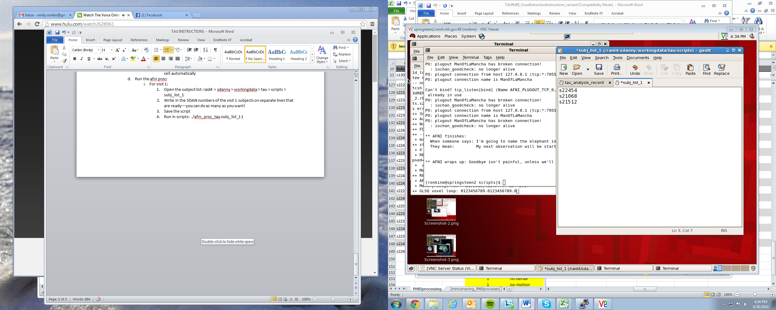
        4. Run in scripts: ./afni_proc_tau subj_list_1 1
     2. For visit 2:
        1. Open the subject list: raid4 > sdanny > workingdata > tau > scripts > subj_list_2
        2. Write in the SDAN numbers of the visit 2 subjects on separate lines that are ready—you can do as many as you want!
        3. Save the script 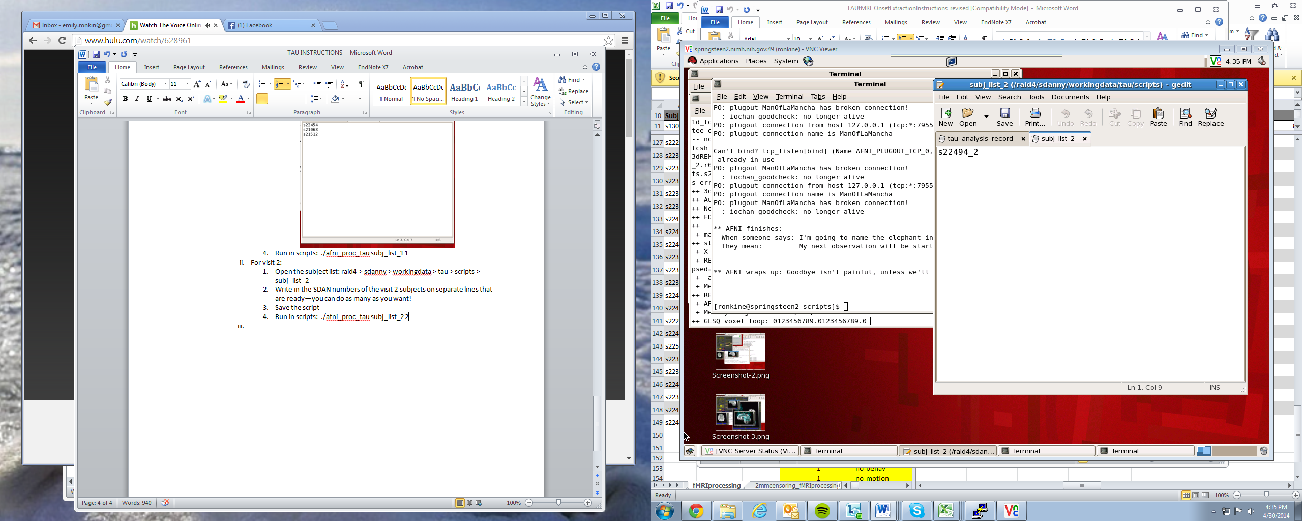
        4. Run in scripts: ./afni_proc_tau subj_list_2 2
     3. These take a while, so you can leave these running overnight
  3. Run the cleanup scripts
     1. Open the subject list: raid4 > sdanny > workingdata > tau > scripts > subj_cleanup
     2. Write in the SDAN numbers of all the subjects who are ready for this step
     3. Save the script: 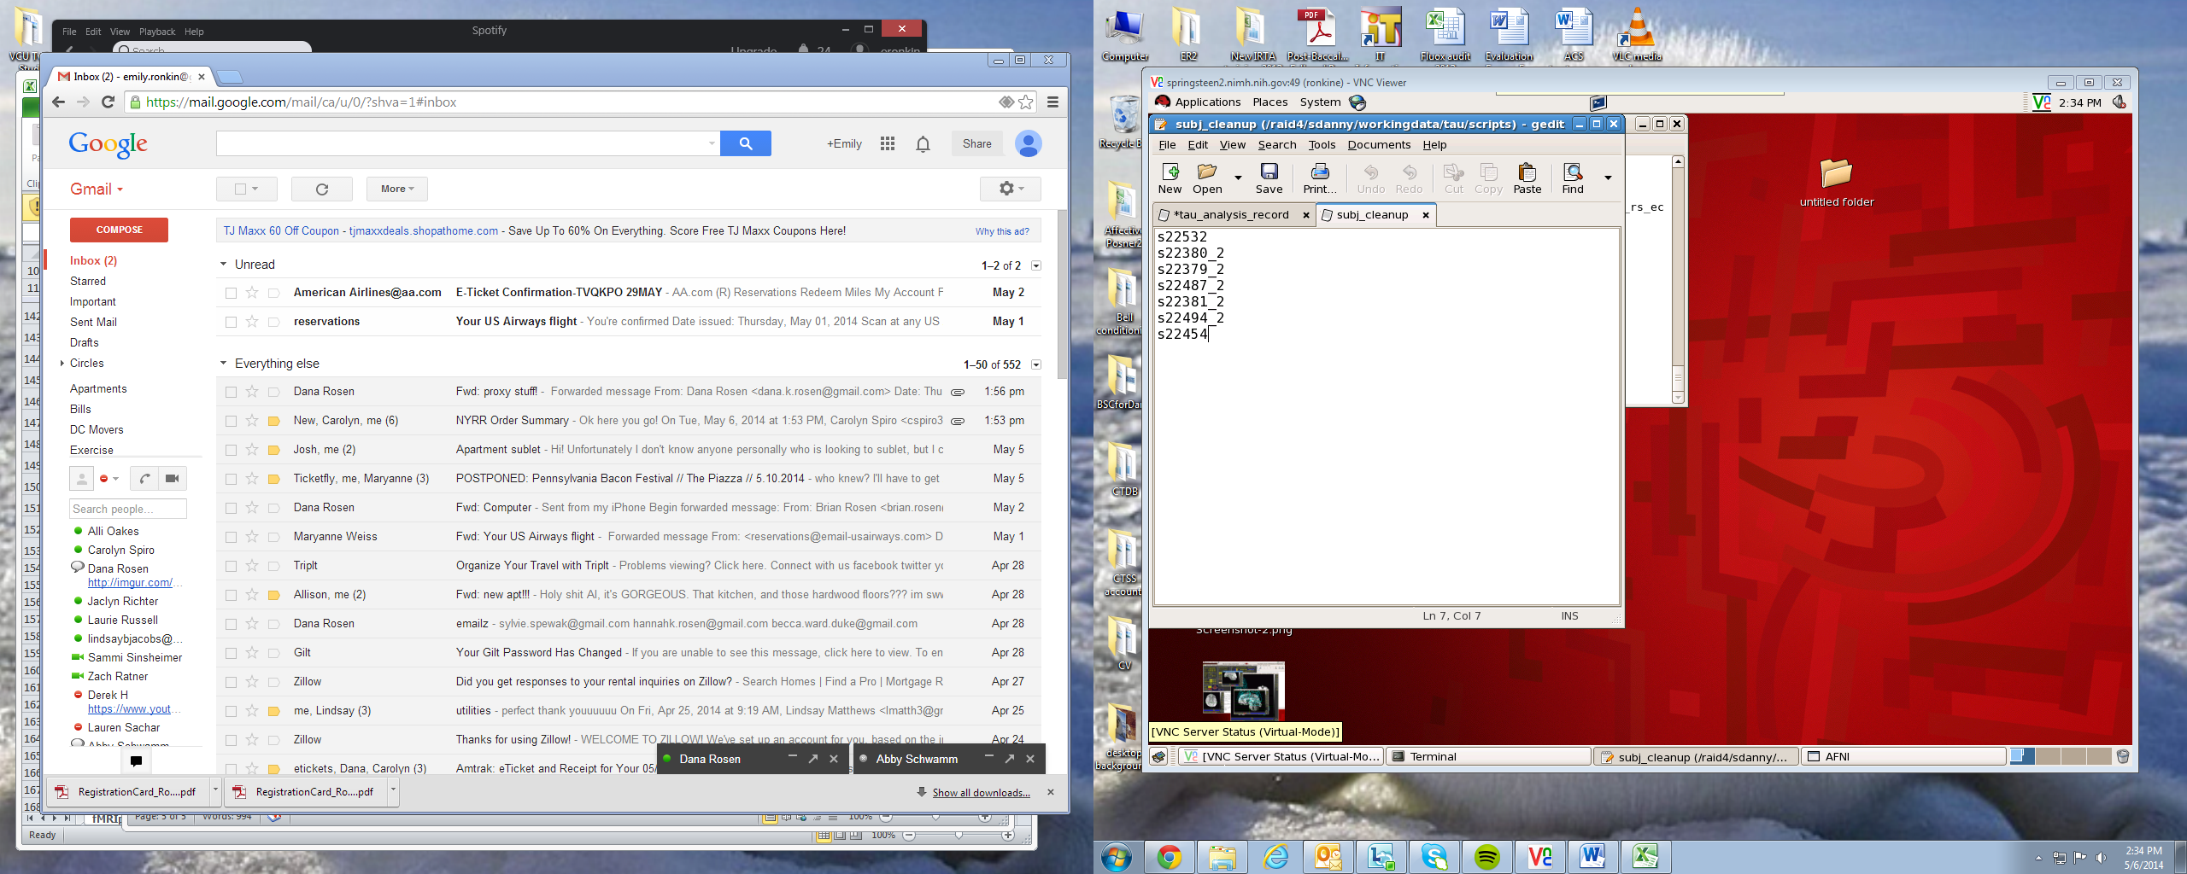
     4. Run in scripts: ./tau_cleanup_dicom subj_cleanup
     5. This should go quickly

1. QUALITY CHECKS: qualitycheck [ID] [visit number]
2. Run the quality checks in scripts
   * 1. What to type:
        1. For visit 1: ./qualitycheck s22532 1
        2. For visit 2: ./qualitycheck s22268_2 2
3. Type in the appropriate command (for visit 1 or 2, see above) in scripts for tau and hit enter
4. A dialog bog box will pop up: “review behavioral data for correct file structure 2 rows of onsets?”
   1. Click “OK”
   2. In the terminal window, 2 rows of numbers will show up for each condition, make sure that the highest number is not higher than 423 (if it is, make a note in the tracker)
      1. There are 4 conditions, use the space bar to move through the 4 in the terminal window checking the numbers
         1. AC: angry congruent
         2. AI: angry incongruent
         3. Incorrect
         4. Neutral
5. Dialog box will pop up “Record number of TRs exceed other motion limits”
   1. Record in the tracker from the terminal:
      1. “Number of TRs that exceed 1”
      2. “Number of TRs that exceed 2”
   2. Click “OK”
6. Dialog box will pop up “Review output from @ss_review_basic…”
   1. Record in the tracker from the terminal:
      1. “num TRs above mot limit”
      2. “average motion (per TR)
      3. “max motion displacement”
      4. “average outlier frac (TR)”
      5. “num TRs above outer limit”
      6. “maximum F stat”
      7. “blur estimates” x3
   2. Click “OK”
7. Dialog box will pop up “review plots”
   1. Three plots will come up. Look at all three (you may need to move graphs around so all three are visible)
   2. Note if the outliers and motion plots match up
      1. Take notes of subjects with extreme numbers of motion and outlier spikes
      2. Limits are noted by red lined across graph. If you don’t see the red line, it means they did not have motion or outliers above these limits
      3. Outlier spikes should roughly correspond to motion spikes. If there are substantially more outlier spikes than motion spikes, note this
      4. This is an example of one where the plots match up well:

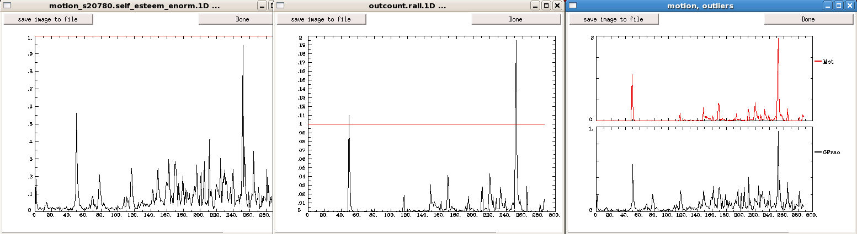

* 1. Click done on all three plots
  2. Click “OK”

1. Dialog box will pop up “review: check alignment between anat and EPI…”
   1. Set underlay to anat file—usually already on anat, but doublecheck
      1. Note if something looks wrong with the brain (warping is weird, missing pieces, etc.)
   2. Set overlay to EPI files (i.e. pb02.s22380_2.r01.volreg) and hit “Set”
   3. Uncheck “see overlay”
   4. Click in the sagittal image of the brain and toggle between the anat and the epi using the “u” key

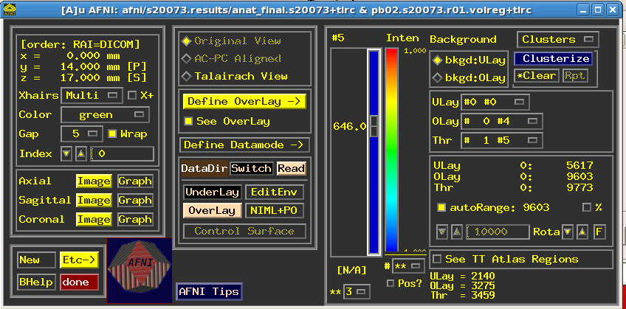

U

EPI ANAT a ANAT

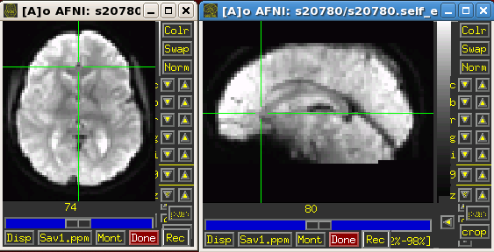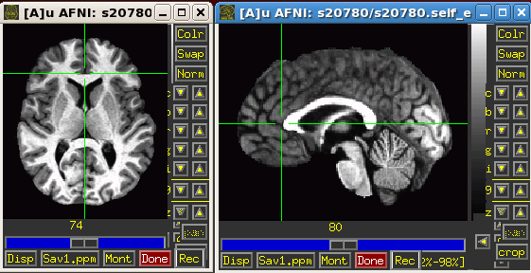

* + 1. CSF should be dark in anat and bright, the corpus callosum should be bright in anat and dark in EPI
    2. Look at the match with anat—follow ventricles and gyral patterns
    3. Click around to several locations: note in tracker if alignment looks off
  1. Close AFNI by double clicking “Done”
  2. Click “OK”

1. Dialog box will pop up “review: check for regression warnings…”
   1. Check in the terminal and note any errors for:
      1. 3d deconvolve
   2. Click “OK”
2. Dialog box will pop up “review: non-baseline regressors in X-matrix…”
   1. You will see two graphs
      1. In X.stim.xmat.1D you should see four rows of graphs—one graph for each condition (AC, AI, Incorrect, Neutral)
      2. In IDEAL_sum.1D you should see many spikes that peak and trough at 1 and 0
      3. Note anything that looks odd, below are examples of what is normal:

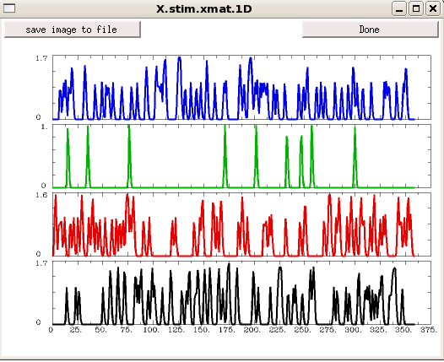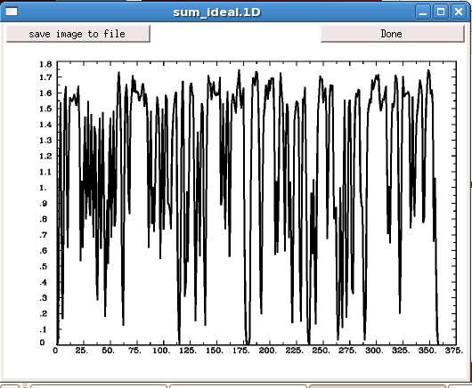

* + 1. Click “Done” at the top of each graph when finished looking
  1. Click “OK”

1. Dialog box will pop up “review: peruse statistical results…”—this is the positive control
   1. AFNI will open with the statistics data as the overlap and the anat as the underlay
      1. ULay should be set to “Full_Fstat”—if not, select and change (see the green circle below)
      2. Olay should be set to “Full_Fstat”—if not, select and change (see the green circle below)
      3. Adjust the threshold bar so that the p value is below the bar p=~.0010
         1. To do so, change “**” to 1 and move the slider up (circled in pink below)
         2. Click “Clusterize” button. In pop up menu select voxels=20 and hit “set” (circled in orange)

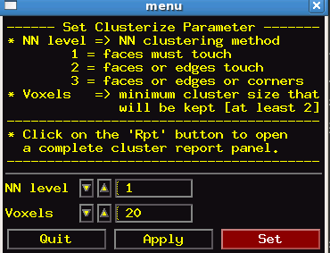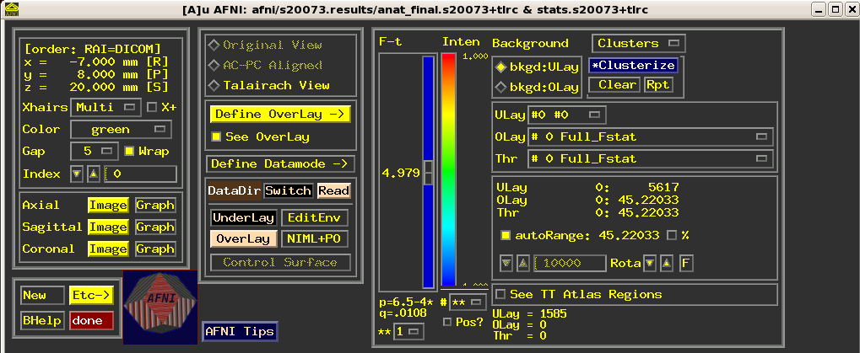

* 1. You should look for activity in the occipital and/or motor cortex—if you do not see it, make a note in the tracker
     1. To look in specific areas, right click on one of the images of the brain and, holding down the right click button, let it go over the choice “Go to atlas location”
        1. Select “Left Fusiform Gyrus” and hit “Apply” and look for activation in that specific area and other areas around; do the same for “Right Fusiform Gyrus”
           1. This is looking for occipital activation
        2. Select “Left Brodmann area 4” and hit “Apply” and look for activation in that specific area and other areas around; do the same for “Right Brodmann area 4”
           1. This is looking for motor cortex activation

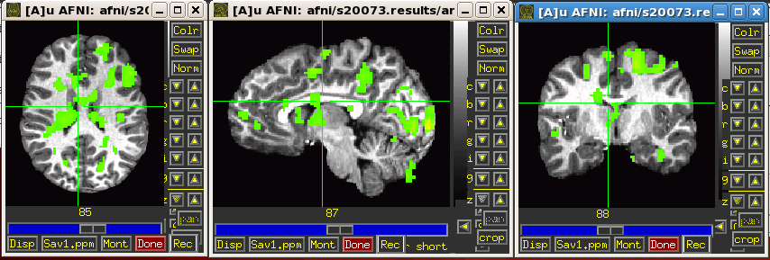

* 1. Double click “Done” in the AFNI window
  2. Click “OK”

1. Dialog box will pop up “Load anat_final and check talaraich…”—this is checking the talaraich
   1. Click “OK”
   2. AFNI window will open—ignore the next dialog box that opens until this step is complete
      1. Right click on the brain, gold down right click button and let it go over “Jump to xyz”
         1. Enter “0 0 0” and hit “Set”
         2. The crosshair should appear at the anterior commissure/posterior commissure (AC/PC) plane
         3. Note that the alignment looks even and the brain look symmetrical
         4. Note anything in the tracker that looks irregular
   3. Double click “Done” in the AFNI window
2. See dialog box that popped up before “Check fits of regression…”
   1. Click “OK”
   2. AFNI window will open—ignore the next dialog box that pops up until this step is complete
      1. Set Underlay to “all_runs.s999 [epan:3D+t:360]*”, hit “Set”
      2. Click “Graph” next to axial
      3. In the bottom right corner of the graphs click “Opt”
      4. Click the box that says “none” next to Tran 1D and choose “Dataset#N”
      5. Check the box to the left of “Input#01”
      6. Click the box “Choose Dataset” and choose the 4th one “afni/s999.results/fits.s999+tlrc”
      7. Hit “Set”
      8. Hit “Set+Close”
      9. Click around in any of the images of the brain and make sure that as you clikc around the red and black lines in the graphs stay matched up—note any irregularities in the tracker
   3. Double click “Done” in the AFNI window
3. See dialog box that popped up before “Check coregistration between anat and epi data…”—this uses addedge as another way to check and align the epi and anat data
   1. Click “OK”
   2. Once AFNI opens, go to the terminal and press enter
   3. Hit enter again to toggle between 2 displays/entries (1) external_volreg_base_ns_s999_ns_ec and (2) external_volreg_base_ns_s999_anat_al_junk_rs_ec
      1. In the window with the 4 crosshairs and 1 sagittal image of the brain, align the crosshairs so that you are seeing more towards the middle of the brain (see image below)
      2. Look at the window with the 4 slices of the brain and toggle back and forth between the junk display and the other display
      3. The blue lines should match up better with the image of the brain when it is on the display called junk
         1. If the junk version is not better, make a note in the tracker

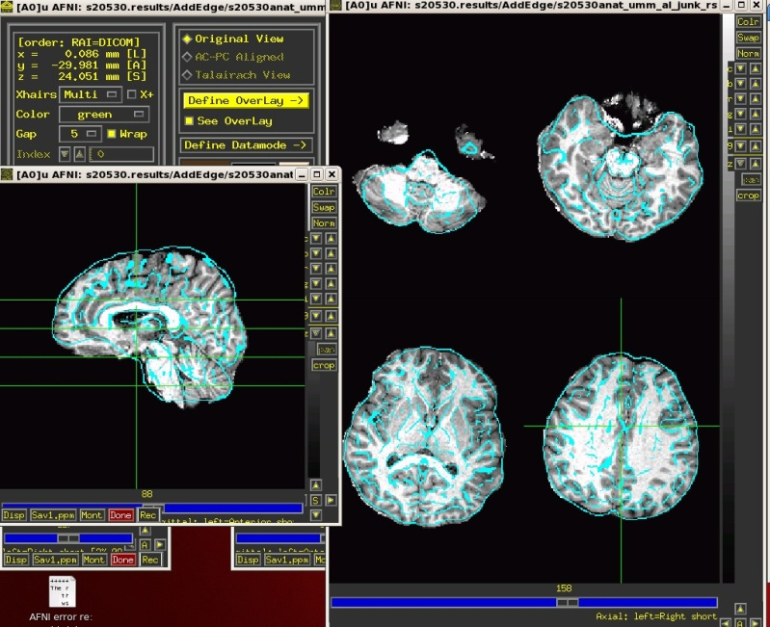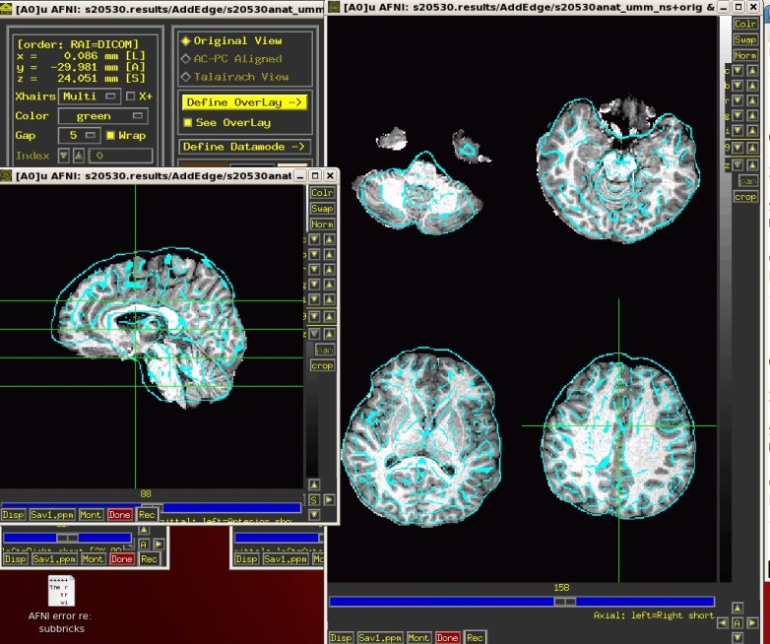

**ENTRY 1:**

**ENTRY 2:**

Look specifically around the corpus callosum, ventricle, and gyri edges. Alignment should get a lot better with Entry 2.

* 1. Double click “Done” in the AFNI window twice (there are 2 AFNI windows opened during this step)

1. Hit Ctrl+C in the terminal window to get back to scripts (you can do this at any point in AFNI to quit out of what you are doing)
2. Run AFNI proc with 2mm censoring. **afni_proc_tau_2mmcensoring [name of file with list of subject IDs] [visit]**

* Run in scripts afni_proc_tau_2mmcensoring
  + Type: tcsh **afni_proc_tau_2mmcensoring subj_list_2mm 1**
* Run spot quality checks
  + Positive Control
    - Go into subject’s results folder: /raid4/sdanny/workingdata/tau/Censoring2mm/InidividualAnalyses2mm/s****/s***.results.2mm
    - 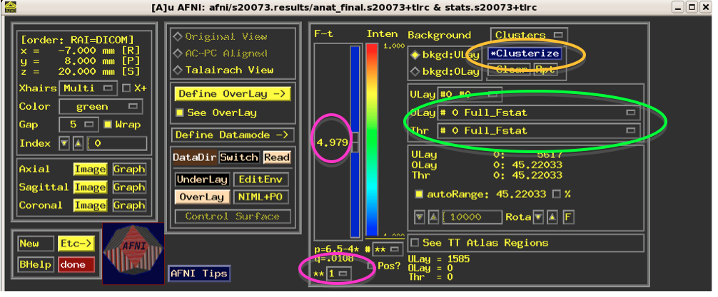Open terminal and enter: afni
      * For Underlay: select Anat.final
      * For Overlay: select stats.s****
      * On right side of screen
        + for Olay: select #0 Full_FStat
        + for Thr: select #0 Full_FStat
      * At the bottom
        + For the ** box, select the “1” option (see below)
        + q should be ~ .005
      * Upper Right, you can select clusterize, then option 20
  + Get SSreview data info
    - Make table
      * tcsh ssreview_table_maker
    - After table is made, to get the data to paste into the processing sheet open the table by:
      * Right click on the file named censor.review,table.xls and select “open with gnumeriv”